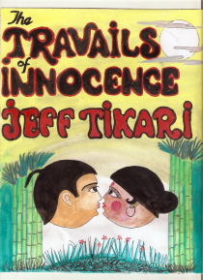

A RECENT WRITE-UP DISCRIBES:
"Jeff Tikari's e-down-loadable book ‘Travails of Innocence a pleasure to read. Fast, suspenseful, and gripping; the story entices one through teenage love and pregnancy and leads one through school life highlighting the disparity between rich and poor pupils then pulls one along to a teen-age Goddess where peoples' gullibility is sadly exposed and finally the tale concludes with a delightful twist that leaves a satisfied after-glow in the mind."
For other gems from Jeff Tikari visit:
http://www.smashwords.com/books/search?query=Jeff+Tikari
OR
http://www.jeffspage.com
contact Jeff at jtikari@gmail.com for a painless free download within minutes.

